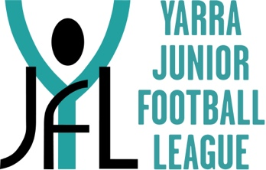
YARRA JUNIOR FOOTBALL LEAGUE

Request For Refund of League Fees
2024 Season
Player First Name
Player Surname
Club
Account Name for Refund
BSB Number
Account Number
Reason for Request
Send Request to | admin@yarrajfl.org.au Attention: Finance Manager

The amount refunded is the total fees less an administration fee of $15.00.

Refund requests will not be accepted after 31st August 2024.

